SaMPLE Analogy Patterns
(These are only a few)

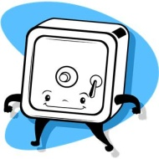
Part-to-Whole
Chapter : Book or the reverse… Bank : Vault
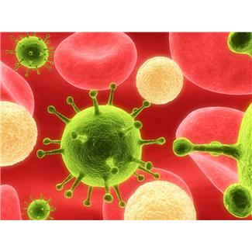
Cause and Effect
Bacteria : Disease or the reverse Laughter : Joke

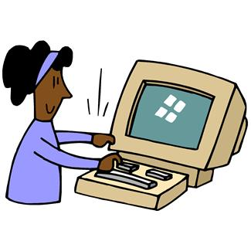
User-to-Tool
Dentist : Drill or the reverse… Computer : Programmer

Tool-to-Product
Computer : Essay or the reverse… Newspaper : Printer
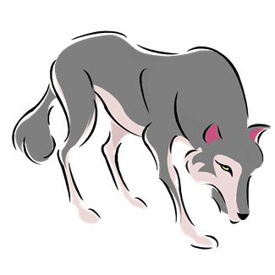
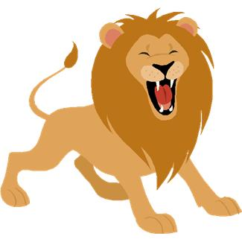
Group-to-Member
Pride : Lion or the reverse… Wolf : Pack

Trait-to-Example
Dishonesty : Lie or the reverse… Diamond : Brilliance

Greater Degree of a Characteristic-to-The Characteristic Itself
Ingenious : Intelligent or the reverse… Extroverted : Brazen

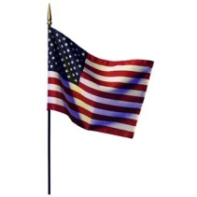
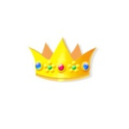
Symbol-to-Institution
Flag : Government or the reverse… Monarchy : Crown

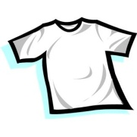
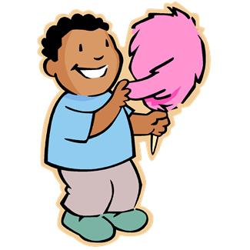
Object-to-Material
Cotton : Shirt or the reverse… Cotton Candy : Sugar

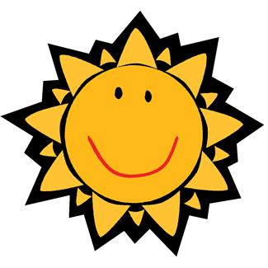
Antonyms
Day : Night Tall : Short Happy : Sad

Synonyms
Happy : Joy Sad : Sorrow Find : Discover

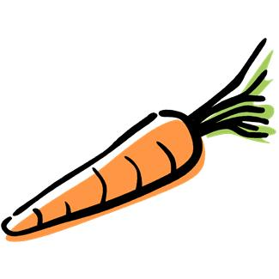
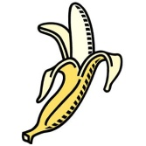
Item-to-Category
Banana : Fruit or the reverse… Vegetable : Carrot

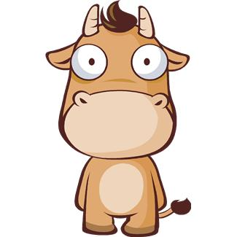
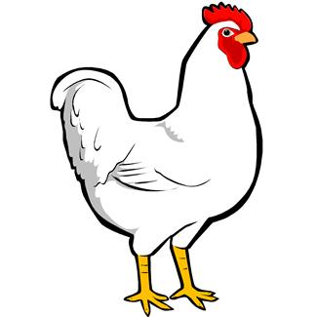
Transformation
Cow : Hamburger or the reverse… Nuggets : Chicken

Defining Characteristic
Pillow : Soft or the reverse… Hard : Brick

