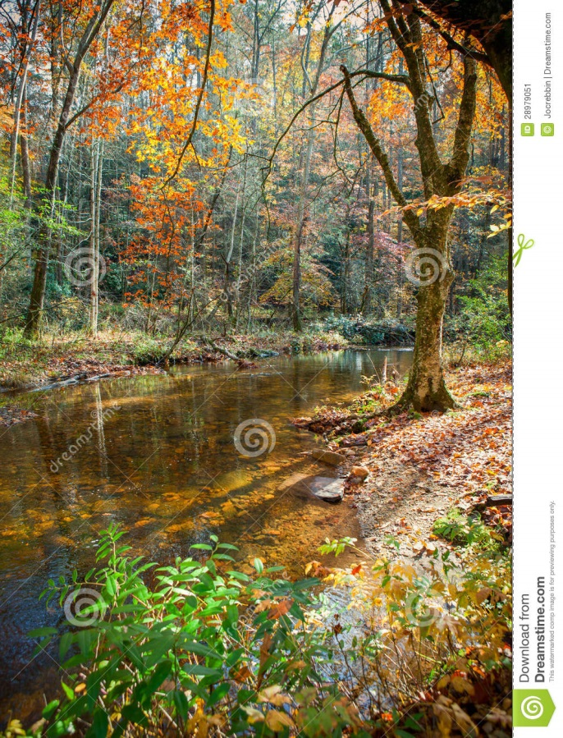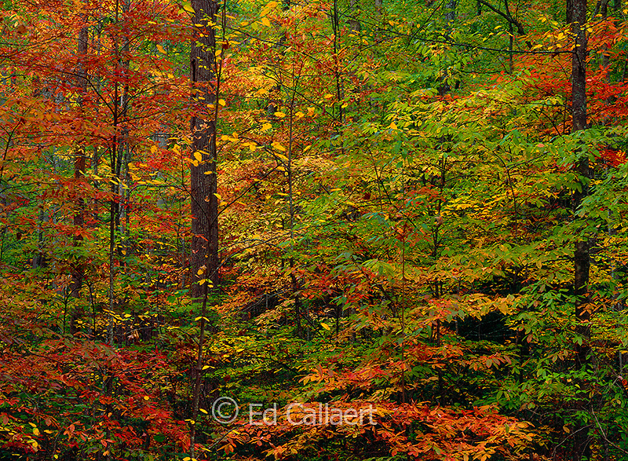
It’s a beautiful fall day and you need to go on a nature hike to collect samples for biology class. You want your friends to go with you but they want to stay in and watch TV. How can you make them change their minds? Write the speech you would give to your friends, persuading them to go on a hike with you. Be sure to include the sights, sounds, and smells of fall. Convince them that hiking in the forest is better than watching television!

