NOVEMBER 6, 2009, 10:36 AM

Complaint Box | Public Grooming
By LION CALANDRA
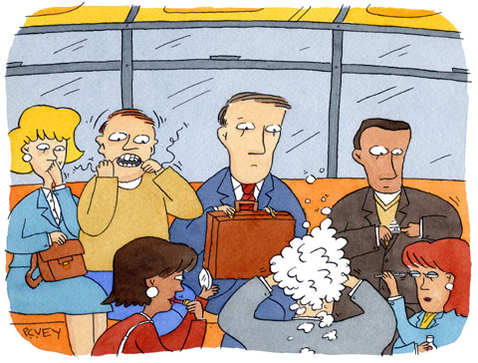P.C. Vey
WHEN did grooming become a spectator sport?
When I was growing up, back in the days when the express train beat the local, straphangers were content to pass their time in transit with a good book or a crossword puzzle. Occasionally, I’d encounter the loud talker, the nose-picker or someone who had to free themselves of a wedgie. Hey, we’ve all been there.
That’s old school.
These days, if someone seated near me on my morning ride is putting on makeup, someone else is clipping his fingernails (and, on one odd occasion this summer, a toenail). Or they’re plucking eyebrows, tying ties, squeezing pimples, even spraying perfume. There are those who just have to bathe themselves in lotion. Others are brushing their hair. It’s the full monty, commuter style.
A few months ago, a woman sitting across from me on a westbound Long Island Rail Road train was flossing her teeth. When she finished, she threw the silky, slimy string on the floor.
“Maybe you should do that at home,” I chided.
“Maybe you should mind your own business,” she said.
“Maybe tomorrow you can shave your legs on the train,” I bellowed.
“Whatever,” said Miss Dental Hygiene.
Whatever, indeed. It takes a village idiot.
The flosser was a special case. Most days, I suffer in silence, fearful of setting off one of those “What are you looking at?” confrontations unique to this city.
We’re all strapped for time. If a person cannot manage to keep personal business personal, then it’s time for a major life overhaul. Yes, it’s hard to juggle life’s obligations. But, for the record, I don’t want to see others plucking their eyebrows or flossing their teeth. I hate to see myself doing it. I also don’t want to be in the cloud of cologne wafting through the air by the mad spritzer sitting 20 feet from me. It irks my allergies. It takes only a few extra minutes before bedtime or in the morning to tend to personal hygiene, which becomes much less hygienic when it’s done on the subway seat where some vagrant just spent the night.
Each season, as summer turns to fall, I hope the cooler weather will end the sideshow. While a cold spell puts some public groomers on ice, others will not be deterred. Last week, on a Manhattan-bound F train, I saw a man combing his hair. When he was finished, he pulled the hairs from the teeth of the comb and sprinkled them on the floor like he was seeding a field. And recently, on my way home to Queens, a woman seated near me on the E train decided it was an appropriate place to remove her nail polish.
I blame YouTube. A modern-day Circus Maximus, the video networking site makes a public spectacle of private moments. Compared with watching a stranger give birth or seeing a man you’ve never met faint during his own nuptials, popping open the new deodorant you just bought at Duane Reade and applying it on the platform of the uptown No. 1 train (you know who you are) is tame.
It cannot be too much to ask for some things to stay private. Maybe the Metropolitan Transportation Authority could do a public service campaign.
A line must be drawn. Just not with dental floss, please.
Lion Calandra lives in Kew Gardens, Queens, and is a freelance copy editor for an Internet content provider.

