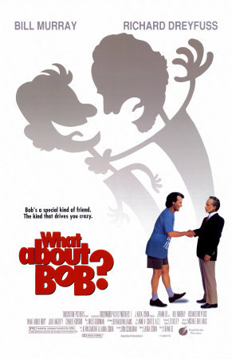Satire and “What About Bob”

Satire: A literary manner which blends a critical attitude with humor and wit to the end (purpose) that human institutions/ humanity may be improved by provoking or preventing change. A satirist is one who satirizes.

Horatian Satire: a comedy of manners, polite, gentle, smiling, aims to correct by gentle and broadly sympathetic laughter

Juvenalian Satire: biting, bitter, angry; it points with contempt and moral indignation to the corruption and evil of men and institutions.

Here are some of the most commonly used devices to create satire.

1. Caricature – A representation in which the subject’s distinctive features or peculiarities are deliberately exaggerated to produce a comic or grotesques effect.

2. Hyperbole – A figure of speech using deliberate exaggeration or overstatement. Hyperbole can often produce irony at the same time.

3. Understatement – The ironic minimizing of fact, understatement presents something as less significant than it is. Understatement is the opposite of hyperbole.

4. Irony – The contrast between what is stated explicitly and what is really meant.

5. Sarcasm – Sarcasm involves language that is meant to hurt or ridicule someone or something. It may use irony as a device but not all ironic statements are sarcastic.

6. Allusion – A direct or indirect reference to something that is commonly known such as a book, myth, place, work of art or event. Allusions can be historical, literary, religious, or mythical.

7. Juxtaposition – Placing dissimilar items, descriptions or ideas close together or side by side, especially for comparison or contrast.

8. Wit - Is a form of intellectual humor. A wit is someone skilled in making/writing witty remarks. Forms of wit include: the quip and the repartee. “Ambrose Bierce styled himself a wit, not a humorist, emphasizing the sardonic and cutting intent of his newspaper columns and stories. ‘Humor is tolerant, tender … its ridicule caresses. Wit stabs, begs pardon — and turns the weapon in the wound.’” ~ Drew Gilpin Faust

Now we will watch the movie What About Bob. Flip your paper over and record as many examples of each of the elements of satire as you can. We will compare our examples at the end of the movie.

Caricature (at least 2)

Hyperbole (at least 3)

Understatement (at least 3)

Irony (at least 2)

Sarcasm (at least 1)

Allusion (at least 2)

Juxtaposition (at least 2)

Wit

