Read the next two selections and answer the questions that follow.

Those Winter Sundays
by Robert Hayden

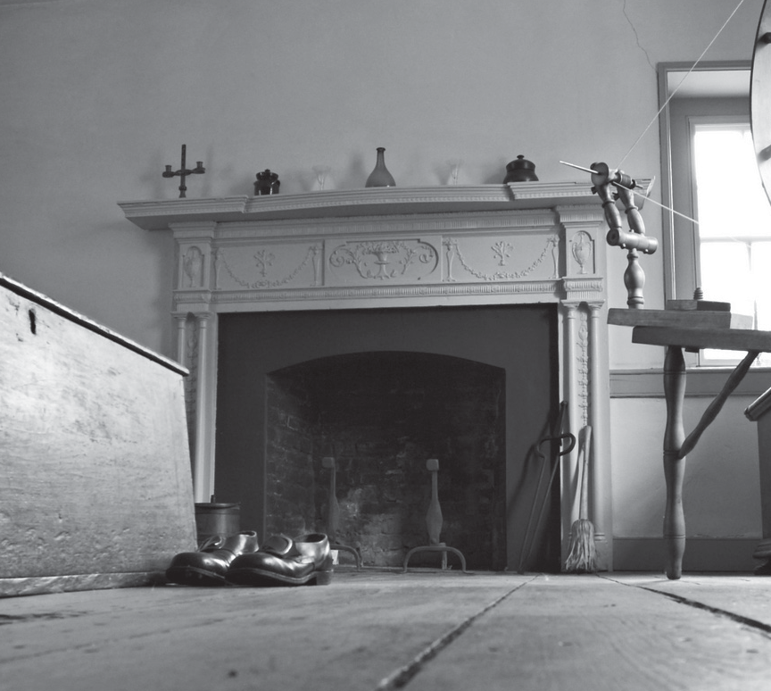

Sundays too my father got up early
© 2007 Marshall Ikonography and World of Stock
and put his clothes on in the blueblack cold, then with cracked hands that ached
from labor in the weekday weather made
5 banked fires blaze. No one ever thanked him.

I’d wake and hear the cold splintering, breaking. When the rooms were warm, he’d call,
and slowly I would rise and dress, fearing the chronic angers of that house.

10 Speaking indifferently to him, who had driven out the cold
and polished my good shoes as well.
What did I know, what did I know of love’s austere and lonely offices?
“Those Winter Sundays” copyright © 1966 by Robert Hayden, from COLLECTED POEMS OF ROBERT HAYDEN by Robert Hayden, edited by Frederick Glaysher. Used by permission of Liveright Publishing Corporation.

All My Babies Are Gone Now
from Loud and Clear
by Anna Quindlen

- All my babies are gone now. I say this not in sorrow but in disbelief. I take great satisfaction in what I have today: three almost-adults, two taller than me, one closing in fast. Three people who read the same books I do and have learned not to be afraid of disagreeing with me in their opinion of them, who sometimes tell vulgar jokes that make me laugh until I choke and cry, who need razor blades and shower gel and privacy, who want to keep their doors closed more than I like. Who, miraculously, go to the bathroom, zip up their jackets, and move food from plate to mouth all by themselves. Like the trick soap I bought for the bathroom with a rubber ducky at its center, the baby is buried deep within each, barely discernible except through the unreliable haze of the past.

- Everything in all the books I once pored over is finished for me now. Penelope Leach, T. Berry Brazelton, Dr. Spock. The ones on sibling rivalry and sleeping through the night and early childhood education, all grown obsolete. Along with Goodnight Moon and Where the Wild Things Are, they are battered, spotted, well used. But I suspect that if you flipped the pages, dust would rise like memories.

- What those books taught me, finally, and what the women on the playground taught me, and the well-meaning relations and the older parents at cocktail parties—what they taught me was that they couldn’t really teach me very much at all. Raising children is presented at first as a true-false test, then becomes multiple choice, until finally, far along, you realize that it is an endless essay. No one knows anything. One child responds well to positive reinforcement, another can only be managed with a stern voice and a time-out. One boy is toilet trained at three, his brother at two. When my first child was born, parents were told to put baby to bed on his belly so that he would not choke on his own spit-up. By the time my last arrived, babies were put down on their backs because of research on sudden infant death syndrome.

- As a new parent this ever-shifting certainty is terrifying, and then soothing. Eventually you must learn to trust yourself. Eventually the research will follow. . . .

- I remember fifteen years ago poring over one of Dr. Brazelton’s wonderful books on child development, in which he describes three different sorts of infants: average, quiet, and active. I was looking for a sub-quiet codicil (see: slug) for an eighteen-month-old who did not walk. Was there something

wrong with his fat little legs? Was there something wrong with his tiny little mind? Was he developmentally delayed, physically challenged? Was I insane? Last year he went to China. Next year he goes to college. He can walk just fine. He can walk too well. Every part of raising children at some point comes down to this: Be careful what you wish for.

- Every part of raising children is humbling, too. Believe me, mistakes were made. They have all been enshrined in the “Remember When Mom Did” Hall of Fame. The outbursts, the temper tantrums, the bad language—mine, not theirs. The times the baby fell off the bed. The times I arrived late for preschool pickup. The nightmare sleepover. The horrible summer camp. The day when the youngest came barreling out of the classroom with a 98 on her geography test, and I responded, “What did you get wrong?” (She insisted I include that.) The time I ordered food at the McDonald’s drive-through speaker and then drove away without picking it up from the window. (They all insisted I include that.) I did not allow them to watch The Simpsons for the first two seasons. What was I thinking?

- But the biggest mistake I made is the one that most of us make while doing this. I did not live in the moment enough. This is particularly clear now that the moment is gone, captured only in photographs. There is one picture of the three of them sitting in the grass on a quilt in the shadow of the swing set on a summer day, ages six, four, and one. And I wish I could remember what we ate, and what we talked about, and how they sounded, and how they looked when they slept that night. I wish I had not been in such a hurry to get on to the next thing: dinner, bath, book, bed. I wish I had treasured the doing a little more and the getting it done a little less.

- Even today I’m not sure what worked and what didn’t, what was me and what was simply life. How much influence did I really have over the personality of the former baby who cried only when we gave parties and who today, as a teenager, still dislikes socializing and crowds? When they were very small, I suppose I thought someday they would become who they were because of what I’d done. Now I suspect they simply grew into their true selves because they demanded in a thousand ways that I back off and let them be. . . .

- The books said to be relaxed and I was often tense, matter-of-fact, and I was sometimes over-the-top. And look how it all turned out. I wound up with the three people I like best in the world, who have done more than anyone to excavate my essential humanity. That’s what the books never told me. I was bound and determined to learn from the experts. It just took me a while to figure out who the experts were.
Reprinted by permission of International Creative Management, Inc. Copyright © 2004.

1. In “Those Winter Sundays,” how does the author use poetic technique to allow the reader to “experience” the cold?

____________________________________________________________________________________________________________________________________________________________________________________________________________________________________________________________________________________________________________________________________________________________________________________________________________________________________________________________________________________________________________________________________________________________________________________________________________________________________________________________________________________________________________________________________________________________________________________________________________

2. In “All My Babies Are Gone Now,” how does the narrator feel about learning to raise children?

____________________________________________________________________________________________________________________________________________________________________________________________________________________________________________________________________________________________________________________________________________________________________________________________________________________________________________________________________________________________________________________________________________________________________________________________________________________________________________________________________________________________________________________________________________________________________________________________________________

3. How are the themes of “Those Winter Sundays” and “All My Babies Are Gone Now” similar? Support your answer with evidence from both selections.

__________________________________________________________________________________________________________________________________________________________________________________________________________________________________________________________________________________________________________________________________________________________________________________________________________________________________________________________________________________________________________________________________________________________________________________________________________________________________________________________________________________________________________________________________________________________________________________________________________________________________________________________________________________________

